**Features**

Features are listed below. **High**, **Medium** and **Low** are used to indicate the importance of each feathers.

|  |  |  |  |
| --- | --- | --- | --- |
| **Feature ID** | **Description** | **Priority** | **Requester** |
| **FE01** | Web based and accessible from devices (with internet connection) such as desktop, laptop, mobile and tablet PCs. | High |  |
| **FE02** | Register and Subscribe through payment | High |  |
| **FE03** | Accessible only to authenticated and authorized users | High |  |
| **FE04** | Data management for example: personal details, tutorials, courses and journals. It will allow other users to view details | Medium |  |
| **FE05** | Buy or enroll courses, journals from other users and post materials | Medium |  |

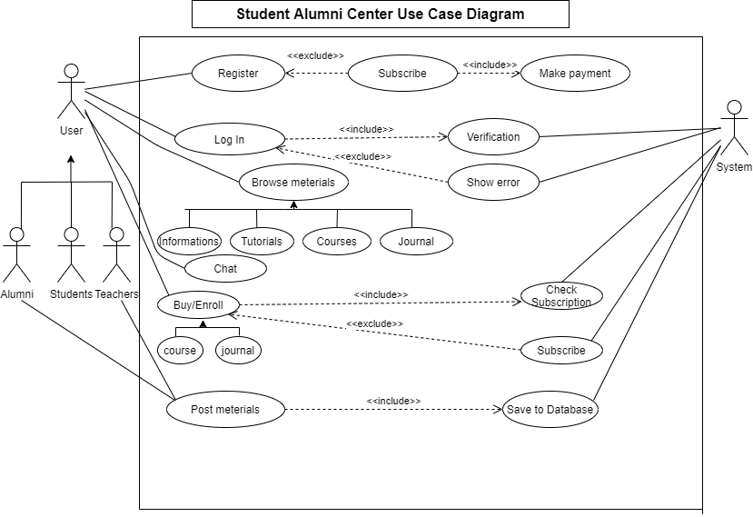

|  |  |
| --- | --- |
| **FE02 - Registration and Subscription** | |
| **Brief Description** | The user opens the portal and the portal shows a form for registration. |
| **Pre-condition/s** | User is not registered. |
| **Priority** | High |
| **Actor/s** | All users. |
| **Main Success Scenario** | 1. User opens the web portal/ application. 2. The system shows a registration form. 3. User enters name, password and payment method. 4. The system allows user to go to login page |
| **Alternative Scenario** | The system will show an error message if the transaction isn’t legit. |
| **Notes/Questions** | Must need to clear payment and ensure subscription. |

|  |  |
| --- | --- |
| **FE03 - Accessible only to authenticated and authorized users** | |
| **Brief Description** | The user opens up the portal and the portal shows the login form for access. |
| **Pre-condition/s** | User is not logged in already |
| **Priority** | High |
| **Actor/s** | All users. |
| **Main Success Scenario** | 1. User opens up the web portal 2. The system displays a login form 3. User enters his/her user id and password 4. The system matches user credentials against its date store 5. The system then redirects user to the appropriate page based on user class. |
| **Alternative Scenario** | * The system cannot find a match for the user and re-displays the login form with an error message. * The system runs into internal error (i.e. database unavailable) and notifies user and asks the user to contact administrator. |
| **Notes/Questions** | Must need clarification on dashboard for each user type. |

|  |  |
| --- | --- |
| **FE04 – User data management** | |
| **Brief Description** | The user is able to update his/her profile. |
| **Pre-condition/s** | User must be logged in. |
| **Priority** | Medium |
| **Actor/s** | All users. |
| **Main Success Scenario** | 1. User can enter his/her personal information e.g., Name, University Id, Passing Year, Contact number, E-mail and Address. 2. User can upload video tutorials and courses. 3. User can display the journal link of his/her thesis paper. |
| **Alternative Scenario** | The system is unable to store the information in database and generates operation not complete message. |
| **Notes/Questions** | The system will not store information from incomplete form. |